TEST PLAN

< Shop Apotheke >

Abstract

This document provides an overview of the project and the product test strategy, a list of

testing deliverables and plan for development

**VERSION HISTORY**

|  |  |  |  |  |  |
| --- | --- | --- | --- | --- | --- |
| **Version #** | **Write by** | **Revision Date** | **Approved By** | **Approval Date** | **Outline** |
| 1.0 | *Huzaif Imtiaz* | *29/07/2022* | *Peter* | *29/07/2022* | Test Plan create |

**INTRODUCTION**

The Test Plan is designed to prescribe the scope, approach, resources, and schedule of all testing activities of the Shop Apotheke.

The plan identifies the items to be tested, the features to be tested, the types of testing to be performed, the personnel responsible for testing, the resources and schedule required to complete testing, and the risks associated with the plan.

**1 TEST STRATEGY**

**1.1 Scope of Testing**

**1.1.1 Feature to be tested**

Login feature which was defined in software requirement specs are need to best

|  |  |  |
| --- | --- | --- |
| **Login Functionality** | Customer | **Customer:** A customer can login to account. |
| **Change Password** | Customer | **Customer:** A customer can change password of account. |
| **New Customer** | Customer | **Customer:** A customer can create new account |

**1.1.2 Feature not to be tested**

These features are not tested because they are not included in the software requirement specs

- User Interfaces

- Hardware Interfaces

- Software Interfaces

- Database logical

- Communications Interfaces

- Website Security and Performance

**1.2 Test Type**

In the project Shop Apotheke, there’re 3 types of testing should be conducted.

- **Integration** Testing (Individual software modules are combined and tested as a group) - **System** Testing: Conducted on a **complete**, **integrated** system to evaluate the system’s compliance with its specified requirements

- **API testing:** Test all the APIs create for the software under tested

**1.3 Risk and Issues**

|  |  |
| --- | --- |
| **Risk** | **Mitigation** |
| **Team members lack the required skills for website testing.** | Plan **training course** to skill up your members |
| **The project schedule is too tight; it's hard to complete this project on time** | Set **Test Priority** for each of the test activity. |
| **Test Manager has poor management skill** | Plan leadership training for manager |
| **A lack of cooperation negatively affects your employees' productivity** | **Encourage** each team member in his task and **inspire** them to greater efforts. |
| **Wrong budget estimate and cost overruns** | Establish the scope before beginning work, pay a lot of attention to project planning and constantly track and measure the progress |

**1.4 Test Logistics**

**1.4.1 Who will test?**

The project should use **outsource** members as the tester to save the project cost

**1.4.2 When will test occur?**

The tester will start the test execution when all the following inputs are ready

- Software is available for testing

- Test Specification is created

- Test Environment is built

- Enough human resource for testing

**2 TEST OBJECTIVE**

The test objectives are to **verify** the Functionality of website Shop Apotheke, the project should focus on testing the **Login operation** such as Logging in with valid CREDS, showing errors when to **guarantee** all these operations can work **normally** in real business environment.

**3 TEST SCOPE**

Testing will cover the functional testing of the Login Functionality.   
Functionality for this release is detailed in the Business requirements documents.

**3.1 In Scope**

Login Functionality

* Forms submissions
* Validations
* Designs
* Responsiveness
* Links accessibility
  + Footer links
  + Header links
* Animations
* Grammar, Text, spellings

**3.2 Out Scope**

Post login activities (like Products pages, Order Workflow). As per this document

**4 TEST CRITERIA**

**4.1 Suspension Criteria**

If the team members report that there are **40%** of test cases **failed**, suspend testing until the development team fixes all the failed cases.

**4.2 Exit Criteria**

Specifies the criteria that denote a **successful** completion of a test phase

- **Run** rate is mandatory to be **100%** unless a clear reason is given.

- **Pass** rate is **80%,** achieving the pass rate is **mandatory**.

**5 RESOURCE PLANNING**

**5.1 System Resource**

|  |  |  |
| --- | --- | --- |
| **No.** | **Resources** | **Descriptions** |
| **1.** | Staging Server | Hosted web server where web services are deployed |
| **2.** | Test tool | Cypress – UI automation VS Code = IDE Rest Assured– api automation Postman – open source to test api’s JIRA - Management tool for bug tracking |
| **3.** | Network | Setup a LAN Gigabit and 1 internet line with the speed at least 5 Mb/s |
| **4.** | Computer | At least for computer run Windows 11, Ram 8GB, CPU 3.4GHZ |

**5.2 Human Resource**

|  |  |  |
| --- | --- | --- |
| **No.** | **Member** | **Tasks** |
| **1.** | Test Manager | Manage the whole project  Define project directions  Acquire appropriate resources |
| **2.** | Test | Identifying and describing appropriate test techniques/tools/automation architecture  Verify and assess the Test Approach  Execute the tests, Log results, Report the defects.  Outsourced members |
| **3.** | Developer in Test | Implement the test cases, test program, test suite etc. |
| **4.** | Test Administrator | Builds up and ensures test environment and assets are managed and maintained  Support Tester to use the test environment for test execution |
| **5.** | SQA members | Take in charge of quality assurance  Check to confirm whether the testing process is meeting specified requirements |

**6 TEST ENVIRONMENT**

The Test Environment should be setup as figure below

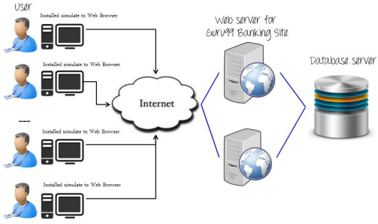

**7 SCHEDULE & ESTIMATION**

**7.1 All project task and estimation**

|  |  |  |
| --- | --- | --- |
| **Task Estimate** | **Members** | **effort** |
| **Create the test**  **specification** | Test Designer | 170 man-hours |
| **Perform Test**  **Execution** | Tester, Test Administrator | 80 man-hours |
| **Test Report** | Tester | 10 man-hours |
| **Test Delivery** |  | 20 man-hours |
| **Total** |  | **280 man-hours** |

**7.2 Schedule to complete these tasks**

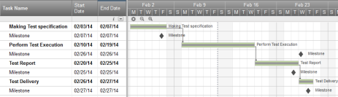

**8 TEST DELIVERABLES**

Test deliverables are provided as below

**8.1 Before testing phase**

- Test plans document.

- Test cases documents

- Test Design specifications.

**8.2 During the testing**

- Test Tool

- Simulators.

- Test Data

- Test Trace-ability Matrix

- Error logs and execution logs.

**8.3 After the testing cycles is over**

- **Test Results/reports**

- Defect Report

- Installation/ Test procedures guidelines

- **Release notes**